

**SOEN 6481**

**SOFTWARE SYSTEMS REQUIREMENTS SPECIFICATION: SECTION SS**

**FALL 2019**

Deliverable 1

Group B

**Team Members**

|  |  |
| --- | --- |
| **Name** | **Student Id** |
| Gunvansh Bhatia | 40082036 |
| Sriparna Chakraborty | 40069488 |
| Vsu Chuchra | 40105218 |
| Ravneet Sing Brar | 40078628 |
| Vasu Dadhania | 40103048 |

**PROBLEM 1. [20 MARKS]**

***BRIEF DESCRIPTION***

iGo is an electronic payment system that makes travelling on transit faster and easier by eliminating the need for tickets, tokens, passes and cash.It works across local transit services in Canada, making paying for your trip simple, convenient and secure.It also allows customers to travel seamlessly across multiple transit agencies with the one electronic fare card by tapping their card at stations and on buses.

It is actively investigating ways to enhance the customer experience such as self-service devices and mobile device applications. The system was designed to accommodate developments in fare payment technology. While iGo currently operates on a closed loop, its system is based on an open architecture, which supports multiple vendors and emerging technologies including contactless debit/credit, near-field communication (NFC) and enhanced online services.

With iGO, it is assumed that metro stations and buses have smartphones/tablets on which the application will be installed, to scan and validate the electronic tickets.With the official iGo app you can manage your card anytime, anywhere.Loading your iGo card has never been easier.You can:

* load funds and transit passes (instant load available on Android devices with NFC)
* receive low balance/pass expiry reminders and email receipts for fare purchases
* pay with Apple Pay and saved payment method
* set up and manage Autoload and Autorenew
* manage multiple iGo cards
* check your iGo card balances
* view your transaction history
* buy a iGo card and create a iGo account

You can download the iGo App now from the Google Play Store or the Apple App Store.The current month's passes are available up to the 8th day of the month. Next month's passes are available as early as 12 days before the end of the month.

You can purchase an iGo Monthly Pass: 1)through the [iGo app](https://www.prestocard.ca/en/about/presto-app) ,2)at one of our [Fare Vending Machines](https://www.prestocard.ca/en/find-an-outlet/fare-vending-machines) or [Self-Serve Reload Machines](https://www.prestocard.ca/en/find-an-outlet/self-serve-reload-machines), located at all iGO metro stations

iGO fares

|  |
| --- |
| $3.10 (Adult) |
| $2.15 (Senior, age 65+ / Youth, ages 13-19) |
| Save up to $1.60 per trip when you transfer between Transits. |
| Monthly pass (Adult - $151.15; Senior/Youth - $122.45) |
| 12 Month Pass (Adult - $138.55; Senior/Youth $112.25) |
| Post-Secondary Monthly Pass ($122.45) |
| iGo Tickets (One-ride - $3.25; Two-ride - $6.50; Day pass - $13.00) |

The Software system must have a Very High Performance, Low-Latency, High Traffic management, Highly Available, Secure, and Accurate.

The payment for the Ticket Purchase is out of scope for this project and will not described in the specifications. However, a Payment option is added which can be extended for realization. Some additional functionalities of the Software include support for multiple Languages.

**PROBLEM 2. [20 MARKS]**

Using the knowledge of a TVM and its (technical as well as non-technical) environment,

construct a context of use model, say, CUIGO, for a TVM.

**NOTE**

There are a number of inevitable constraints. For example, it is conceivable that certain

context of use factors of a TVM, such as positive or negative stakeholders, are difficult to

elicit for a variety of reasons, including legal constraints. This is because certain

stakeholders of a TVM cannot be known publicly for a variety of reasons, including

confidentiality. Therefore, CUIGO may have to be ‘incomplete’ by necessity. The

rationale for scoping CUIGO should be highlighted accordingly.

***CONTEXT OF USE for Ticket Vending Machine***

The context for the ticket vending machine is specific for the public transportation. The application would be designed for the mobile, is customized accordingly. The context of use model has been described in the below diagram where the centralized concept is the iGO TVM which is deployed in on the mobiles. The users are using it for generating the tickets for public transportation like busses and trains etc. The software development team on the other hand would be responsible to implement the design and produce the software for the people to use on day to day basis.

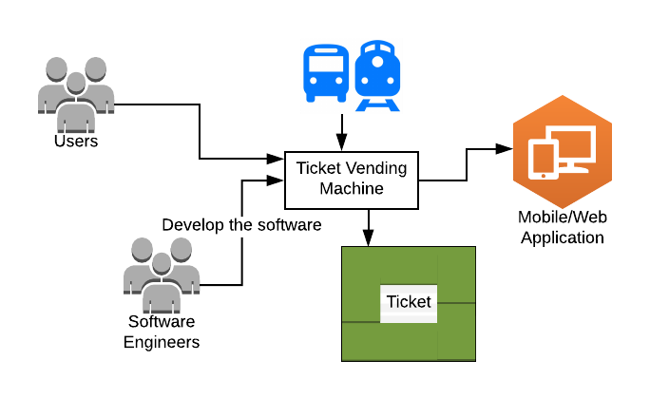

Figure 1. Context of diagram for Ticket Vending Machine (Source: [Keeling, 2017, Chapter 16].

Framework of Context of use Model: [CUIGO]

|  |  |  |
| --- | --- | --- |
| TYPE OF FACTORS | ATTRIBUTE | DETAILS |
| **User** | Age | >6 |
|  | Skill | Able to interact and read instruction set |
|  | Education | Basic Details |
|  | Training |  |
|  | Experience | Previous experience counts with the similar type of TVM |
|  | Mental /Physical Attribute | Mentally presence and physically activeness is needed. TVM should be accessible if the users are blind or physically challenged |
|  | Attention | Full attention needed |
|  |  |  |
| **User Task** | Task specific goals | A complete and successful transaction from user side .for example -1.printing ticket  2. printing receipt |
|  | Criticality of task | Priority high due to the reason that user might be in rush to reach his/her destination. |
|  | Frequency of use | No restriction for user in multiple purchase of ticket in a single day |
|  | Dependency on use | Database connection and power breakage is inacceptable. |
|  | Duration of use | 3 minutes of idle state will bring the user back to its home page. |
|  | Risk from error | If at any time user makes a mistake they can always go back or cancel current transaction. |
|  |  |  |
| **User Role** | Admin | 1.Network Administrator  2.Security Engineer  3.Software Engineer |
|  | Registered | Users with a valid iGO card. |
|  | New user non-registered | Users or non frequent travelers with no iGO card and are interested in buying tickets according to their needs. |
|  |  |  |
| **User Goal** | Criticality | Highly Critical |
|  | Overall Goal | A complete and successful transaction from user side. |
|  |  |  |
| **User Activity** | Sitting | Physically challenged user with for example a wheelchair person should be able to use TVM. |
|  | Standing | User should be able to use TVM in standing position. |
|  | Others | Children >6 or blind user should have proper access to TVM |
|  |  |  |
| **Location and Time** | Location | Available near to every metro station even on the streets |
|  | Time | Ticket will be purchased according to local time zone |
|  |  |  |
| **Natural Environment** | Light | Proper lighting needed even in the brightest day to see the display for all users |
|  | Temperature | TVM will be on the street .So Temperature will play a major role here. |
|  | Sound | Specially for physically challenged users the sound from the system should be in perfect pitch. |
|  |  |  |
| **Technical Environment** | Hardware |  |
|  | Screen | Interface with proper button options to select any options. |
|  | Keyboard | Keyboard should be made keeping in mind all kind of users and OK,CANCEL and CLEAR button will be there in GREEN,RED and YELLOW colour. |
|  | Software |  |
|  | Server | Server will be running 24/7. It will accept payment gateways as well. Every transaction will be recorded in the IGO database. |
|  | Operating System | IGO will be using any preferable OS on market. |
|  | Network |  |
|  | Connectivity | It will be running 24/7. |
|  | Stability | It should be stable enough to run in a real world with real users. |
|  |  |  |
| **Social Environment** | Ethical Standard | It should follow standard Canadian ethics. |
|  | Legal Constraints | It should follow all the legal rules made by Transport Canada |